*Add process flow chart or simulated image of prototype or any relevant image related to your idea*

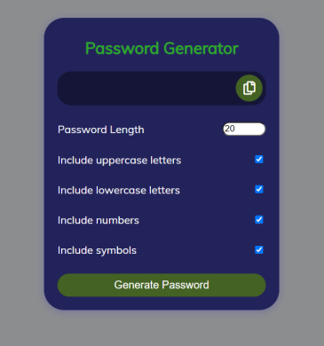

**Idea/Approach Details**

| *Describe your Idea (Problem Statement), Proposed Solution and Methodology here*  ***Create a password generator that is simple to use and safe. It should produce strong passwords that combine uppercase and lowercase letters, digits, and special characters. The generator need to support customizing***  ***While maintaining unpredictability and resistance to hacking methods, password length and character constraints should be adjusted to suit the needs of the various platforms or organizations. The solution should be scalable to effectively manage high quantities of password generating requests and should offer clear instructions and a smooth user experience across numerous devices.*** |
| --- |
| *Describe the features / functions of the concern work here*  ***Users will be able to alter the length and character types of the passwords generated thanks to the password generator's robust and secure password generating algorithm. While offering a user-friendly interface with clear instructions and visible feedback, it will guarantee randomization and resilience to hacking techniques. The generator will be usable offline and accessible from a variety of devices. It will have a password strength indicator, manage password histories, and be scalable to effectively handle massive numbers of password generating requests. Overall, it will give users the ability to generate secure, distinctive, and customised passwords, improving their online security****.*  *Describe your required technologies / facilities to complete the prescribe work here*  ***The required technologies for the password generator include a strong randomization algorithm to ensure randomness and uniqueness in generated passwords. Additionally, cryptographic functions will be necessary to securely store and retrieve password histories. A user-friendly interface can be built using web development technologies such as HTML, CSS, and JavaScript, ensuring cross-platform compatibility. The generator may leverage backend technologies like Python or Java to handle password customization and generation. To ensure scalability and quick response times, cloud services or server infrastructure may be employed. Overall, a combination of randomization algorithms, cryptography, web development technologies, and scalable infrastructure will be essential for the password generator's implementation.*** |

**Signature of Faculty In Charge**